SPENDWISE
INTRODUCTION
TEAM ID:2026-9328
TEAM SIZE :5
TEAM LEADER :S.SRUTHI & sruthisivasamy22@gmail.com
NM I©D:7ECD932886135AB7ACB2420985766F592
TEAM MEMBER:V.MOHANAPRIYA & mohanaverappan31@gmail.com
NM I©D:886C1A53A736AC0C473F865451F5A
TEAM MEMBER:S.PREETHI & saravananpreethi70@gmail.com
NM I©D:37F3700C7D7899DB55040702E867416D
TEAM MEMBER:K.RAGAVI & ragavisabari4@gmail.com
NM I©D:D6858B9CCDFE37089A544C2EDF79044C
TEAM MEMBER:A.RAMYA & ramyaananth2007@gmail.com
NM I©D:OD9D56816523FB5A00E413B1A5863489
Project Overview
SpendWise is a backend application designed to help beginner developers learn how to build secure RESTAPIs using Node.js,Express,MongoDB,and JWT authentication. The project focuses on implementing user authentication and basic CRUDoperations in a clean and simple wayso students can understand how backend systems work in real-world scenarios.
KeyObjectives:
Provide secure user authentication using JWT
Enable basic CRUDoperations on user data (transactions/records) Demonstrate MongoDBintegration using Mongoose
Show how protected routes work using middleware Maintain a simple and beginner-friendlybackend architecture
Target Users:
Beginner backend developers
Students learning Node.js and Express
Freshers preparing for technicalinterviews
Anyone who wants a simple project to understand JWTand MongoDB
Learners who want hands-on practice with RESTAPIs
Project Instruction
SpendWise is a backend-onlyproject built using Node.js and Express. Quick Start:
npm init npm install npm run dev
Steps to Create the Project:
Choose or create a directoryfor the backend project.
Open terminaland navigate to that directory. Initialize Node.js project using npm init.
Installrequired packages:express,mongoose,jsonwebtoken,bcrypt,cors,dotenv.
Create folders:models,routes,controllers,middleware,config. Start the server using npm run dev.
Test APIs using Postman or Thunder Client at http://localhost:5000.
Pre-requisites:
Software Requirements
Software Purpose

Node.js MongoDB npm
Git
Code Editor
JavaScript runtime for backend NoSQLdatabase for data storage
Package manager Version controlsystem VSCode or similar

Knowledge Requirements
JavaScript ES6+
Node.js and Express.js MongoDBand Mongoose JWTauthentication
Basic RESTAPIconcepts Git basics
ThumbnailforProject
Asimple backend project thumbnailrepresenting:
Node.js +Express +MongoDB+JWT+CRUDAPIs
Project Architecture Image
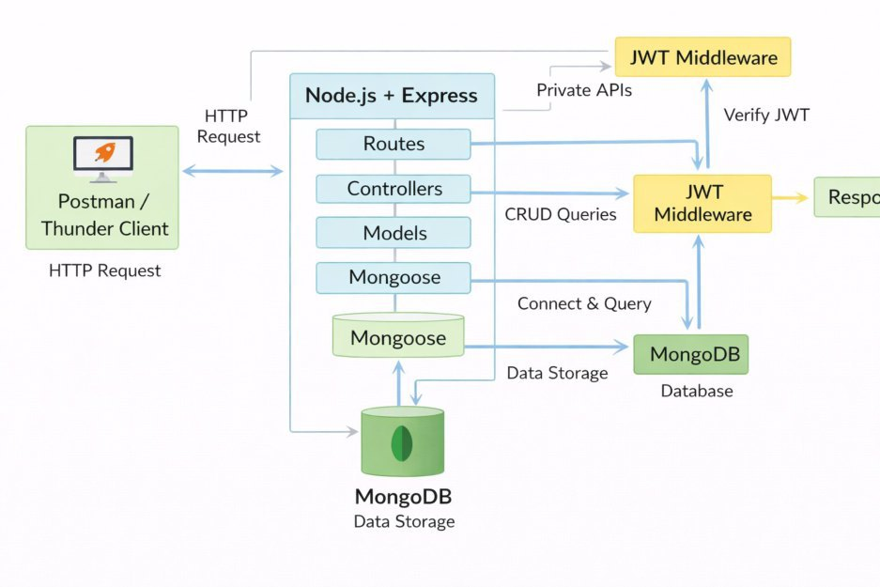
TechnicalArchitecture
Backend Architecture (Node.js + Express)
Controllers:Handle business logic for authentication and CRUD Models:Mongoose schemas for User and Transaction Routes:APIendpoints for auth and CRUDoperations Middleware:JWTverification and request protection Configuration:Database connection and environment variables
Database Architecture (MongoDB)
Users Collection:
_id,name,email,password (hashed),createdAt Transactions Collection:
_id,userId (FK),title/description,amount/value,createdAt Relationship:
ManyTransactions belong to One User
ERDiagram
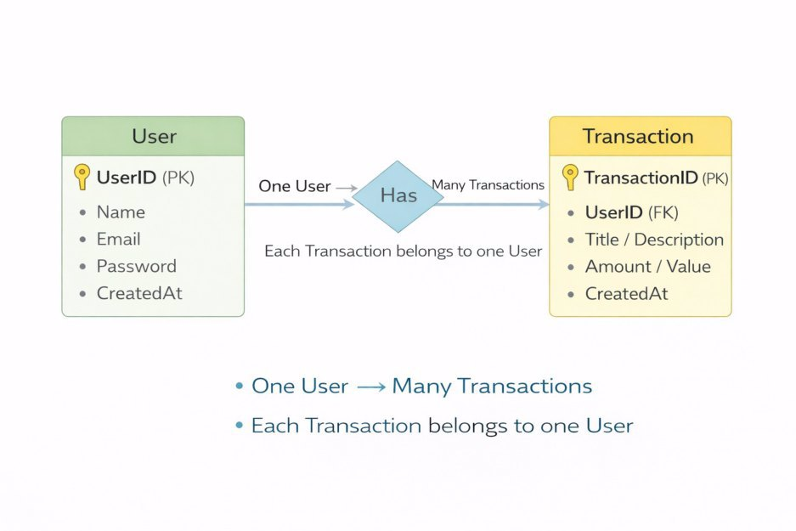
Features

Feature User Authentication
CRUDOperations Protected Routes MongoDBIntegration
Description
JWT-based registration and login Create,Read,Update,Delete transactions Secure APIs using JWTmiddleware Store and fetch data using Mongoose

Roles and Responsibilities
Student / Developer:
Write backend code Create APIs
Test APIs using Postman/Thunder Client Push code to GitHub
System (Backend):
Authenticate users using JWT Handle CRUDoperations
Store and fetch data from MongoDB Protect private routes
Users Flow:
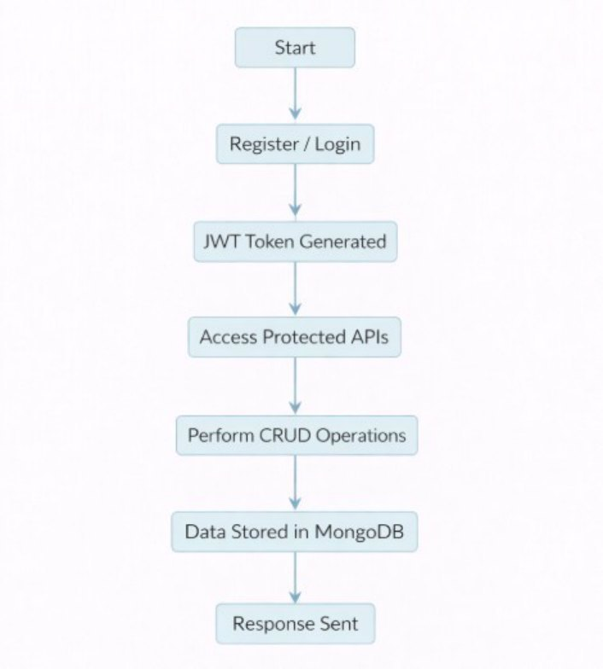
PROJECTSETUP ANDCONFIGURATION
Folder Structure
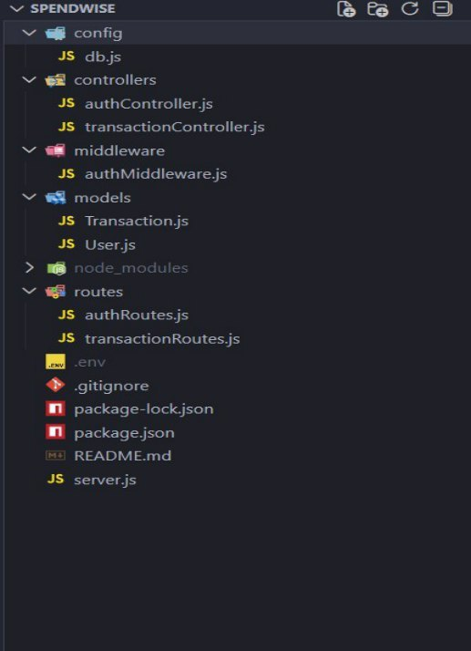
Project Setup
- Installrequired tools:
Node.js MongoDB
- Create project folders:
server folders (models,routes,controllers,middleware,config)
- InstallBackend Packages: Express
Mongoose
Cors
Jsonwebtoken
Bcrypt Dotenv
BACKENDDEVELOPMENT
Setup Express server
Create server.js file
Create .envfile and define PORTand DBURL
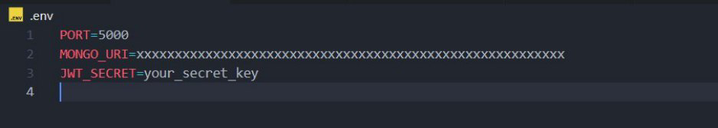
Configure middleware (cors,express.json) User Authentication:
0 Create Register and Login routes
Generate JWTtoken
Protect routes using middleware
Define APIRoutes:
0 Auth routes
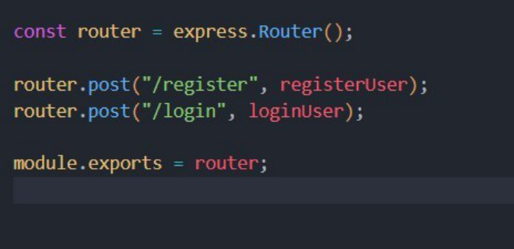
Transaction CRUDroutes Implement Data Models:
0 User schema
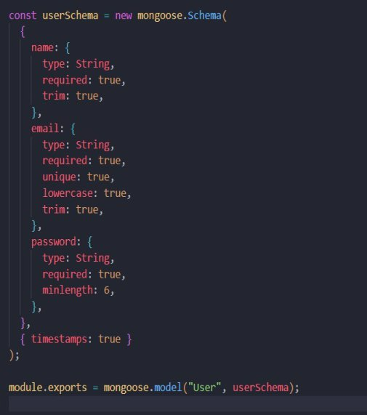
Transaction schema
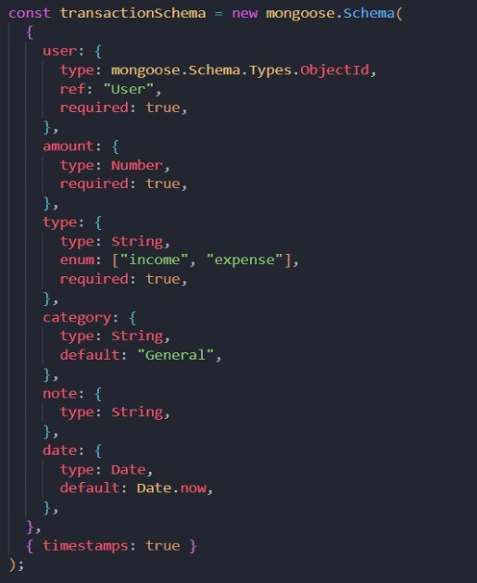
Implement CRUDoperations Add basic error handling
DATABASEDEVELOPMENT
Configure MongoDB
Use MongoDBAtlas or localMongoDB Store connection URLin .envfile Connect using Mongoose
Create Database Connection
Create a config file for DBconnection
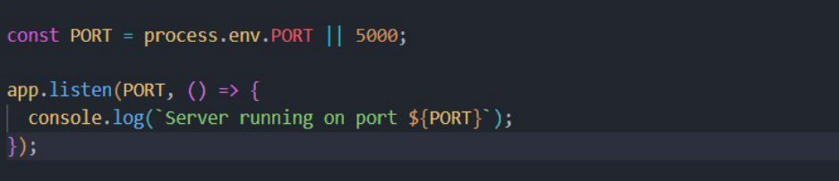
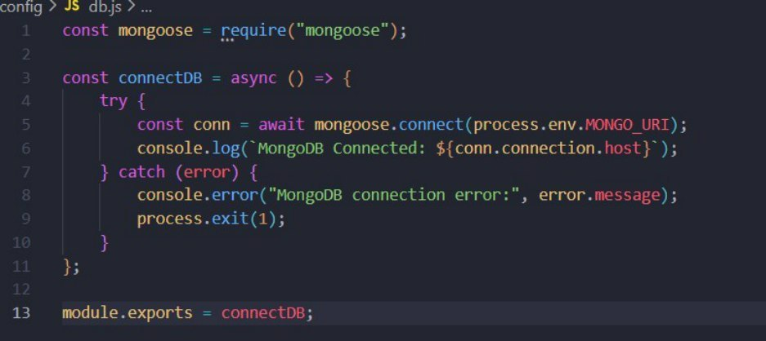
Use mongoose.connect() Handle success and error cases
Create Schema and Models
UserModel:
Name email password
Data / Transaction Model:
userId
title / description amount / value
timestamps
PROJECTEXECUTION
Project Execution Steps:
- Start MongoDB
- Run backend server
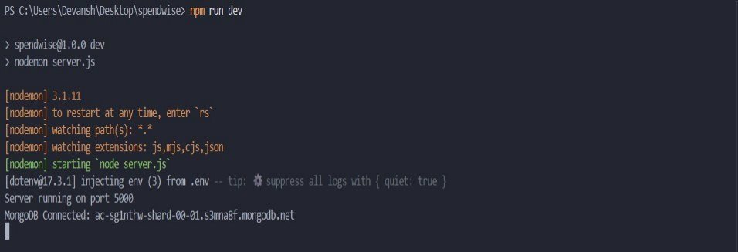
- Test Register API
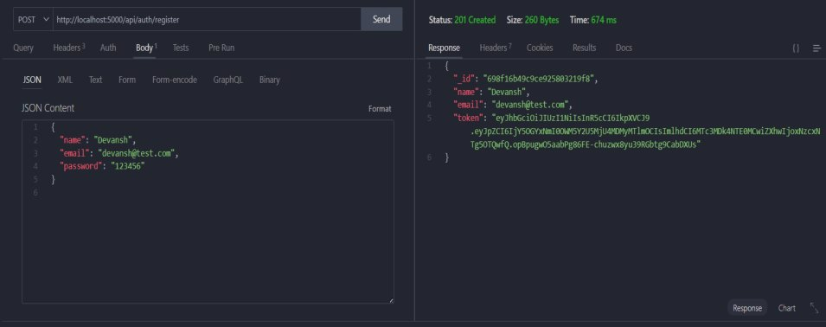
- Test Login API
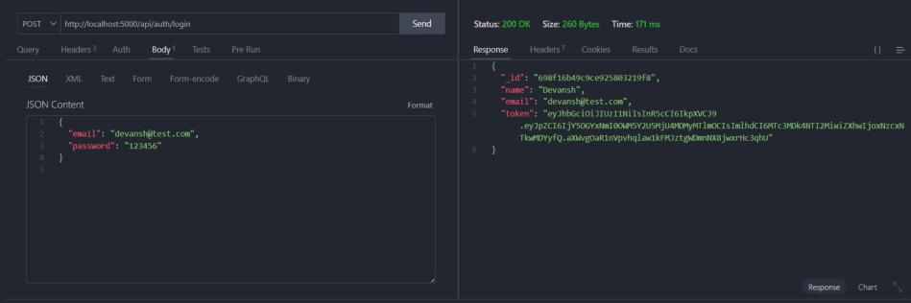
- CopyJWTtoken
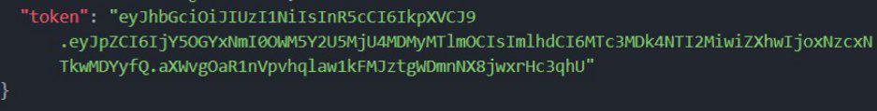
- Use token to access protected CRUDAPIs
- Perform Create,Read,Update,Delete operations
OUTPUT SCREENSHOT
- Register API
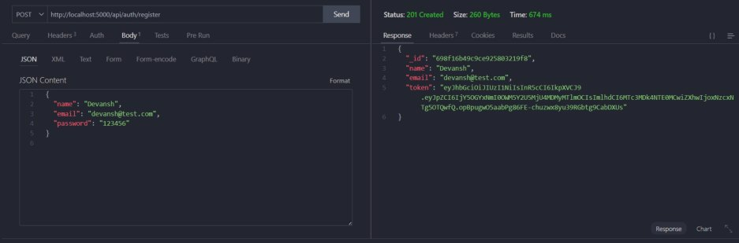
- Login API
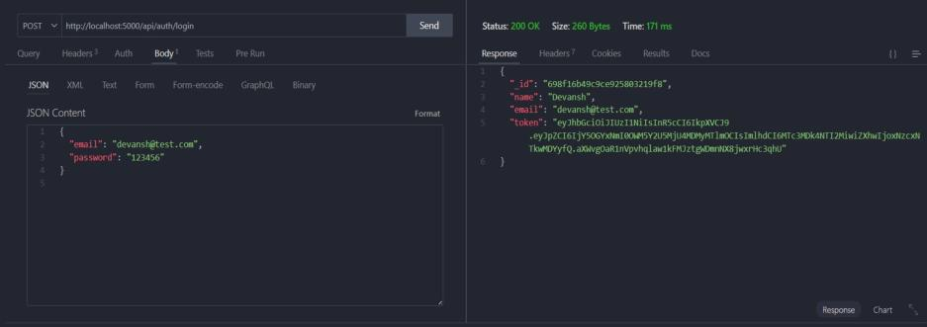
- Create Transaction
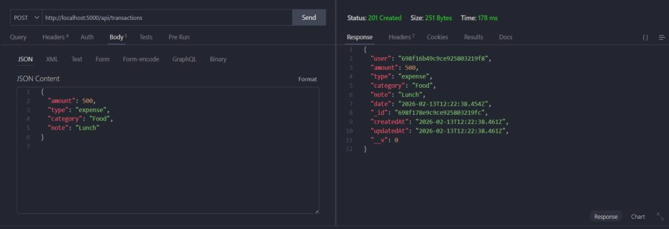
- Get information
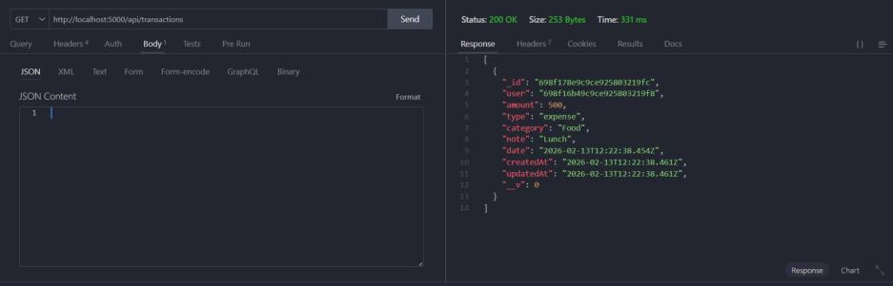
- Update API
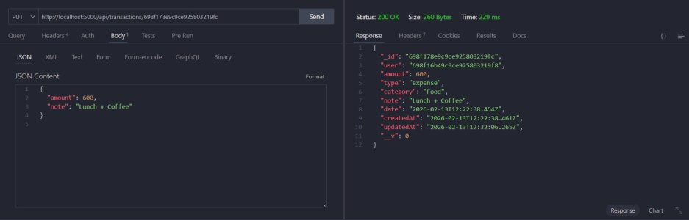
- Delete API
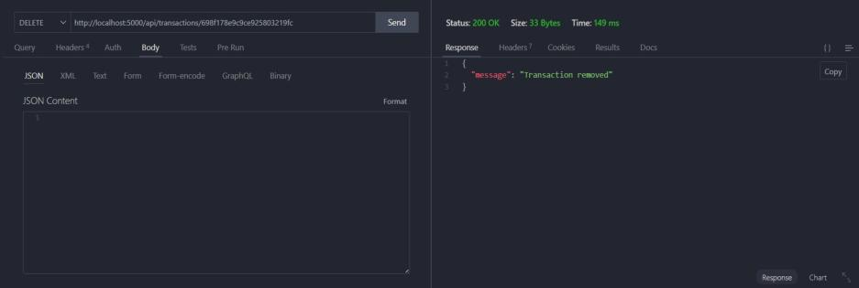
Project Demo Video
SpendWise (video).mp4
https://github.com/maheswaris731-gif/Spendwise.gitDrive Link:SpendWise

